Project Development Phase
Performance Test

Date | 26 October 2026
Team ID | Individual
Project Name | Electric Vehicle Market Analysis Dashboard
Maximum Marks

Project Performance Testing:
Project team shall fill the following information in model performance testing template.
S.No. | Parameter | Screenshot / Values
 | Data Rendered | EV dataset connected as a Tableau data source (Data Source tab). Fields rendered: Category, Manufacturer, Battery Type, Annual Sales Units, Avg. Range Km, Avg. Customer Rating and production country/location.
 | Data Preprocessing | [Confirm/edit: data checked for nulls and duplicates, field types and names standardised (Category, Battery Type, Manufacturer) before building the 9 sheets]
3. | Utilization of Filters | [Confirm/edit: filters applied on the sheets, e.g. Category, Manufacturer and Battery Type]
4. | Calculation fields Used | Calculation1 (used on the Sales Volume & Revenue Contribution by Vehicle Category sheet). [Add any other calculated fields you created]
5. | Dashboard design | No of Visualizations / Graphs - 9 (Dashboard 1: 4 visuals, Dashboard 2: 5 visuals)  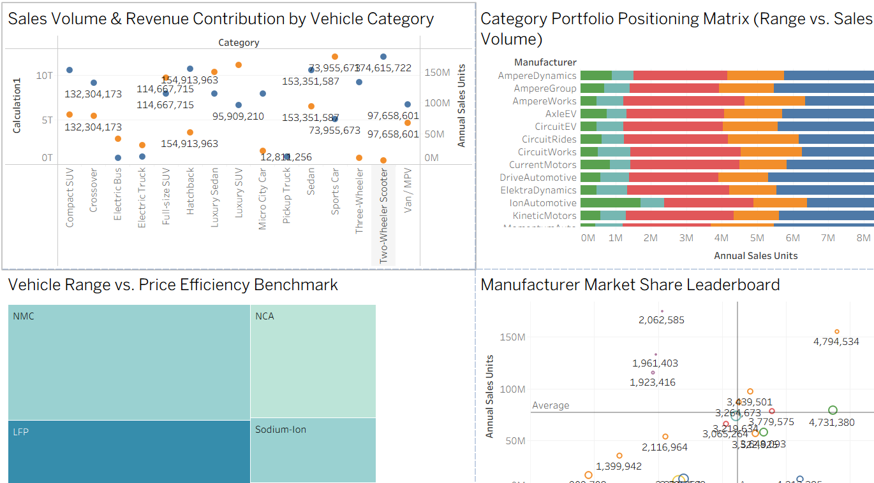  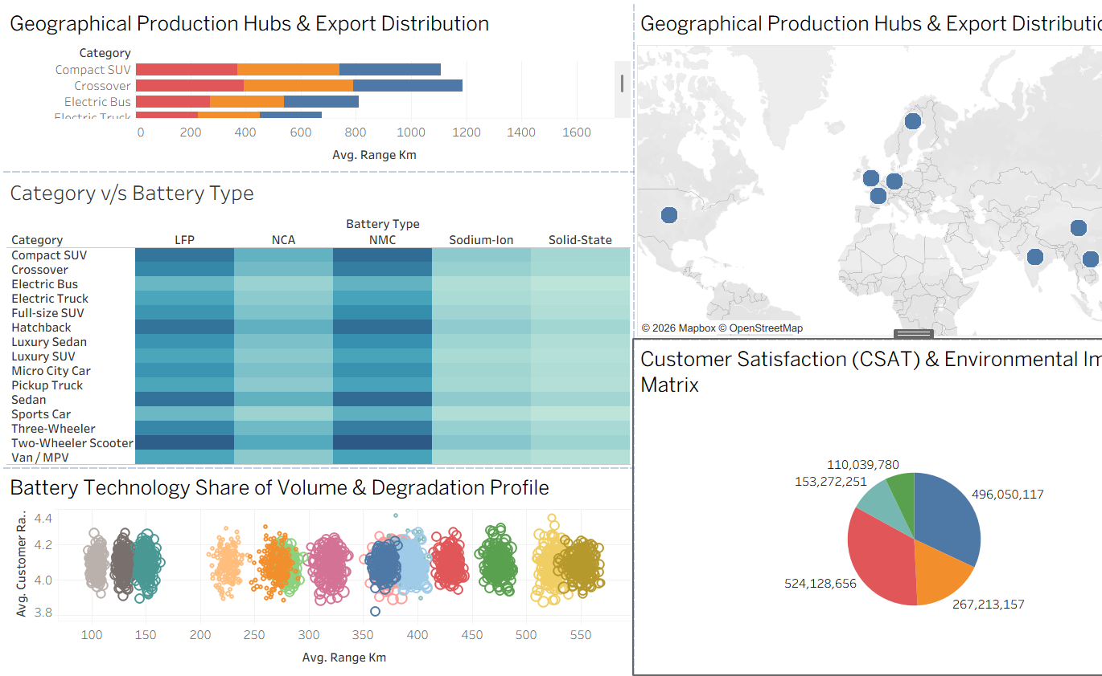
6 | Story Design | No of Visualizations / Graphs - 9 (story built from the 2 dashboards)

